

AZ Bookings

Project Engineering

Year 4

Ashar Zafri

Bachelor of Engineering (Honours) in Software and Electronic Engineering

Galway-Mayo Institute of Technology

2021/2022

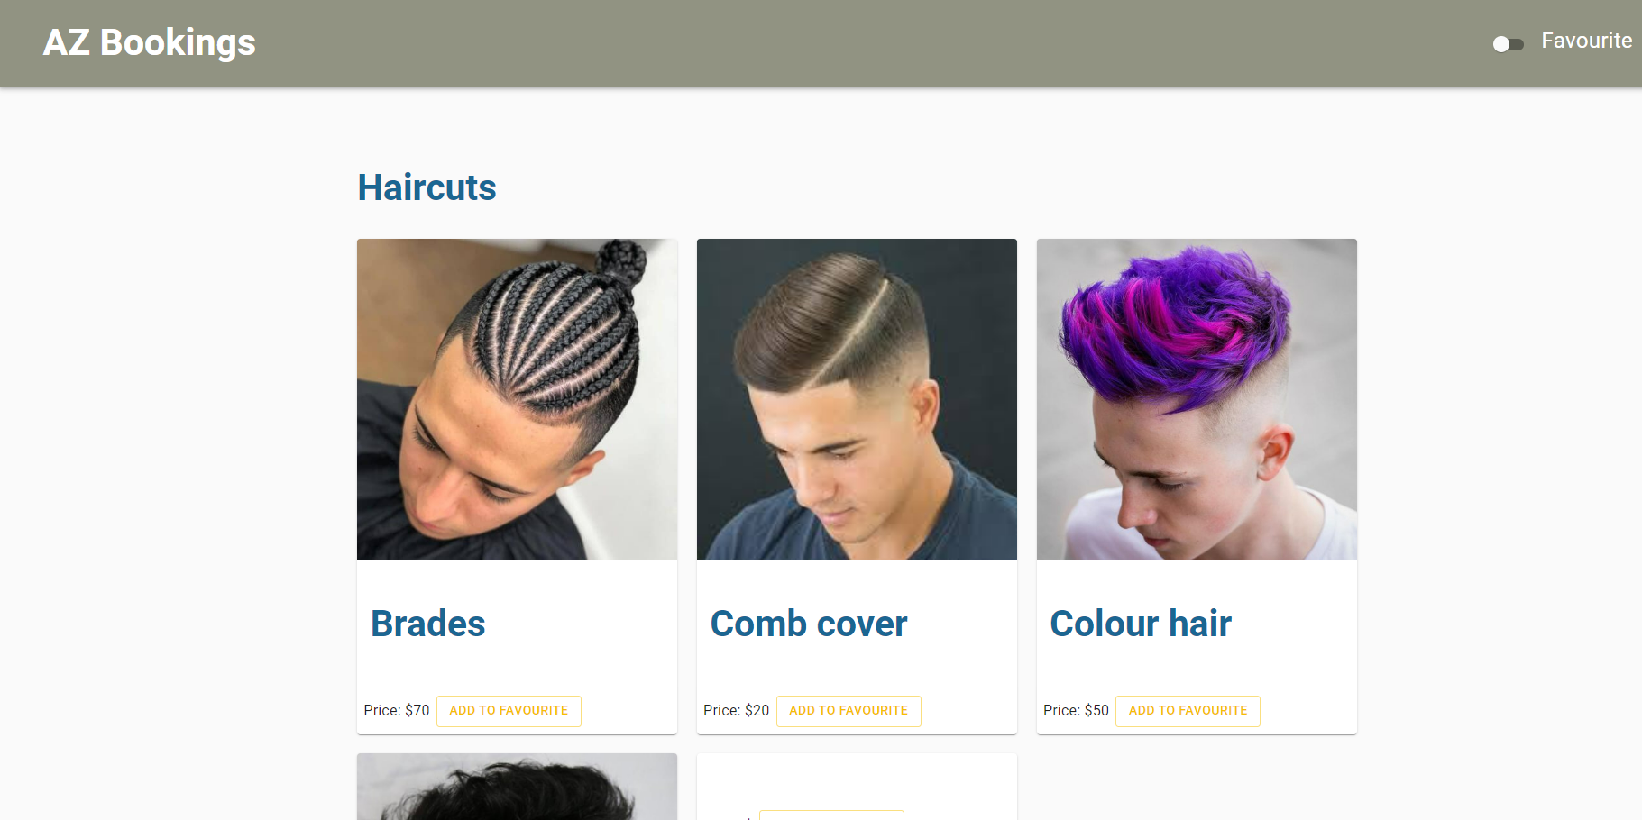

**Declaration**

This project is presented in partial fulfilment of the requirements for the degree of Bachelor of Engineering (Honours) in Software and Electronic Engineering at Galway-Mayo Institute of Technology.

This project is my own work, except where otherwise accredited. Where the work of others has been used or incorporated during this project, this is acknowledged and referenced.

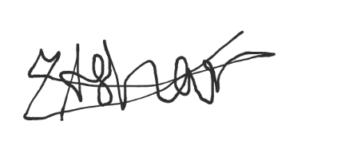  
___________________________________

**Acknowledgements**

My professors Nail OKeffe, Paul Lennon, Michelle Lynch, and my supervisor Brain O Shea all supported me in the development of my project. I am grateful for all of my lecturers' support and help.

**Table of Contents**

1 Summary 6

2 Poster 7

3 Introduction 8

4 Project Architecture 9

5 Project Plan 10

6 Front End 11

6.1 HomePage 11

6.2 Notes on Content 11

7 Challenges 11

8 Conclusion 12

9 Appendix 13

10 Reference 14

# Summary

I'm going to develop a barber booking web app for my senior project. During Covid, I had this thought. Due to restrictions, barbers could only have a certain number of customers at a time once the lockdown began. Covid resulted in long lines and overcrowding at barbershops. Az booking will help customers to select a time when the barber is available and avoid waiting time by using this Web app.

AZ Bookings is an online booking application that allows customers to choose their barbers and opening slots, based on barber availability.

A NextJS frontend and a NodeJS backend are used in this project. AWS (Amazon Web Services). hosts both the frontend and the backend. Az booking has been designed to be as user friendly as possible

On the other hand, Barbers will be able to update availability and mark successful bookings. Barber will also be able see missed appointments by customer. Moreover, Barber should be able to update prices.

To make this possible, I will be using React, HTML, and JavaScript as codebase. NoSQL database through AWS cloud to retain customer data (customer/barber accounts and schedules).

# Poster

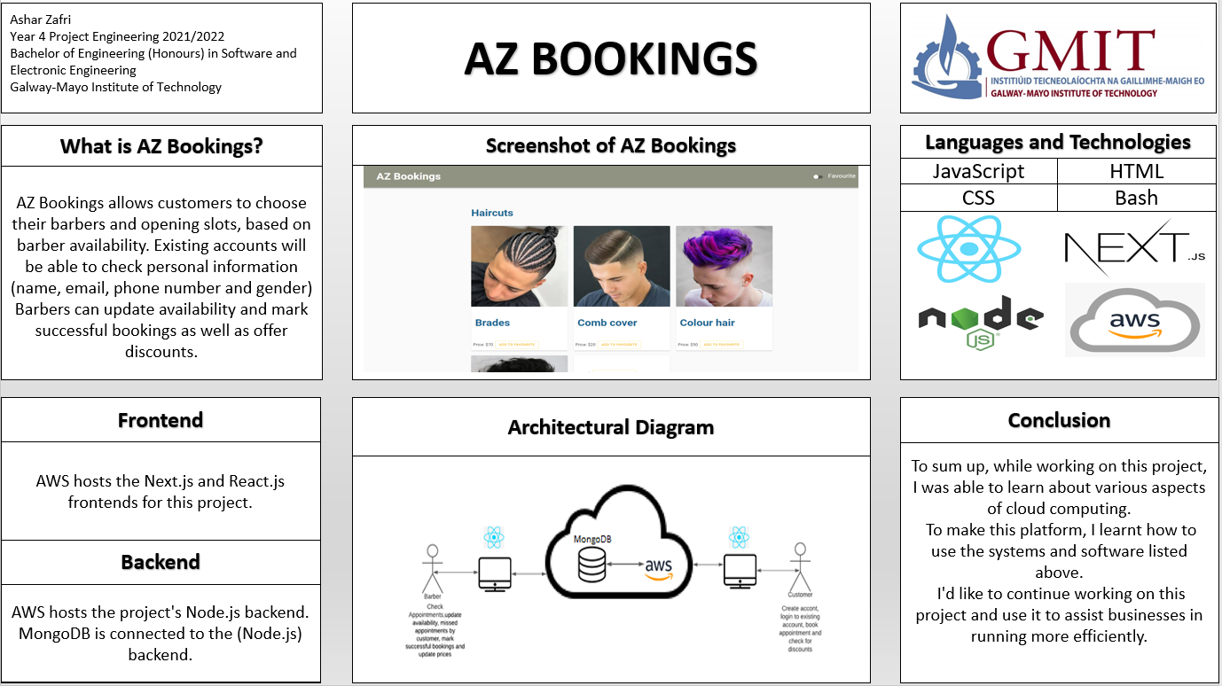

# Introduction

AZ Bookings is an online booking application that allows customers to choose their barbers and opening slots, based on barber availability. AZ Bookings work with an account where you can create a new one or log in with a current one. Existing accounts will be able to check personal information (name, email, phone number and gender), previous bookings, give discounts (based on the number of bookings).

On the other hand, Barbers will be able to update availability and mark successful bookings. Barber will also be able see missed appointments by customer. Moreover, Barber should be able to update prices.

To make this possible, I will be using React, HTML, and JavaScript as codebase. NoSQL database through AWS cloud to retain customer data (customer/barber accounts and schedules).

# Project Architecture

As stated previously, this project is divided into two parts: the frontend and the backend. Both Nextjs (frontend) and nodeJS(backend) are hosted on Amazon Web Services. MongoDB is installed so that the backend may send and receive information from the database.

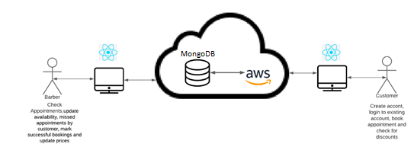

Figure ‑ Architecture Diagram

# Project Plan

This project required a great deal of planning. This enabled me to stay on top of my project. The project's schedule is depicted in the Gantt chart below. In the first semester, I focused on frontend development. In the second semester, I worked on the project's front and back ends. In addition, once we've finished with cloud computing, I'll worked on AWS.

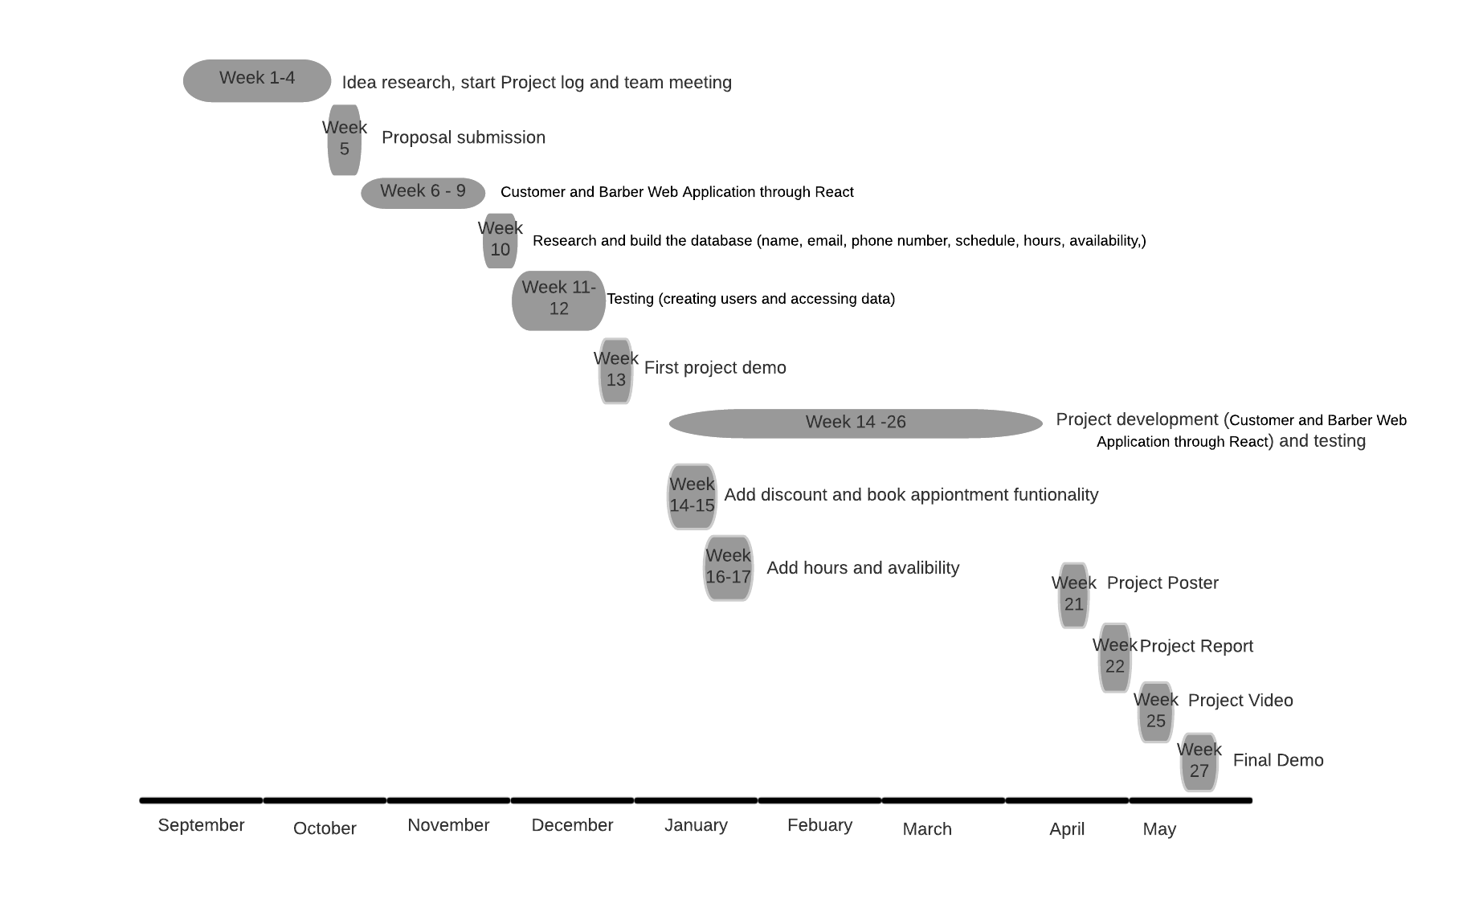

# Project

In my project I have used different cloud computing technologies. I have used React and nextJS to

## omePage

## Notes on Content

# Challenges

I faced a variety of problems while working on this project. This was my first time working on a full stack project. I needed to learn how to use javaScript and react. My development was slowed because of this.

In the first semester, my laptop had stop functioning. I had lost all of my work on that computer and had to start again with my project.

In addition, in the second semester, I decided to switch from React to nextjs for my project. When I switched from react to nextJS for my pages and components. I came across quite a few errors. After trying to fix the problem for a while, I was suggested to move the files to a new nextJS project. This resolved the problem.

Moreover, I was attempting to connect Robo 3T 1.2 to MongoDB. I was unable to establish a connection to MoongoDB. This was frustrating because I was able to add data to MongoDB. I was unable to remove sample data from the database, though. After doing some investigation, I discovered that many other people were experiencing the same problem, and that the remedy was to download Robo 3T 1.3. I was able to miniplate the data and delete the unwanted data as a result of this solution.

# Conclusion

To sum up, while working on this project, I was able to learn about various aspects of cloud computing. To make this platform, I learnt how to use the systems and software listed above. I'd like to continue working on this project and use it to assist businesses in running more efficiently.

# Appendix

# Reference

1. [React Crash Course for Beginners 2021 - Learn ReactJS from Scratch in this 100% Free Tutorial!](https://www.youtube.com/watch?v=Dorf8i6lCuk&t=5044s)  Used to start project page navigation and page layout with CSS
2. <https://pretagteam.com/question/how-can-i-create-a-global-array-in-react-when-i-do-separate-operations-for-each-index-i-want-them-to-save-them-in-a-single-array>  Will be used to learn how to store multiple values in a single array
3. <https://dev.to/yezyilomo/you-can-definitely-use-global-variables-to-manage-global-state-in-react-17l3> Use to learn about global object
4. <https://dev.to/yezyilomo/you-can-definitely-use-global-variables-to-manage-global-state-in-react-17l3> Use to learn about global object
5. <https://tinloof.com/blog/how-to-build-an-auto-play-slideshow-with-react/>  For a slide show that I can use to  display picture or adds
6. <https://www.w3schools.com/w3css/w3css_modal.asp> How to set up modal
7. <https://www.geeksforgeeks.org/how-to-create-a-simple-responsive-footer-in-react-js/> Used to help set a footer
8. <https://codesource.io/how-to-use-this-props-history-push-on-your-react-project/> How to use push function
9. <https://www.w3schools.com/> Will be used to learn, test and research css and html
10. <https://www.npmjs.com/package/@material/textfield> To be able to use the text field
11. <https://backup.ninja/news/database-backups-101-file-and-database-compression> Method of reducing file size in data bases
12. <https://wisebarber.com/types-of-haircuts-for-men/> colour hair pic
13. styleinterest.com/low-fade-hairstyles/  Fade image
14. <https://www.newstore88.top/products.aspx?cname=taper+cornrows&cid=58>  Brades image
15. <https://pretagteam.com/question/how-can-i-create-a-global-array-in-react-when-i-do-separate-operations-for-each-index-i-want-them-to-save-them-in-a-single-array>  Will be used to learn how to store multiple values in a single array